**What are ElectroManetic Waves?**

1) How are they produced?

a) ______________ and _____________ fields are constantly changing

b) EM waves are produced when electric charges vibrate or ______________

2) How they travel

a) Since electric and magnetic fields are constantly changing, they ____________ each other

b) EM waves can travel through a _______________ (empty space) as well as through

matter

**Wavelength and Frequency:**

* Short wavelength -->
  + high frequency
  + high ______________
* Long wavelength -->
* small _______________________
* low energy

**Radio Waves**

-__________________ wavelength

-Lowest Frequency

1) Radio waves are used in radio & TV technologies, as well as _________________.

a) Radio

1) Amplitude modulation (AM)

2) Frequency modulation (FM)

b) Radar

1) Send out short bursts of radio waves that __________ off objects & return to

receiver

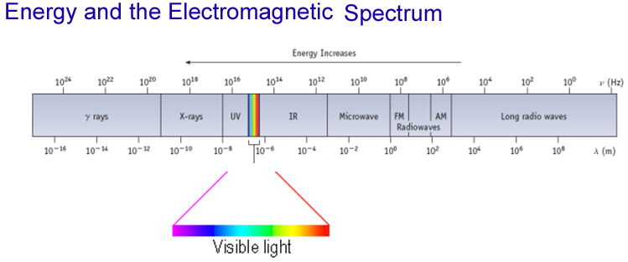

**Check for Understanding: (Use the pictures in the Power Point to review the following answers.)**

Which has the longest wavelength: Radio Waves

Rank the following in order of increasing frequency:

Radio, microwaves, infared, red light, blue light, Uv light, x rays

**Waves:**

* Waves have a _______________________
* Use the Greek letter “nu”, n, for frequency, and units are “cycles per sec”
* All radiation: l • n = c
* c = velocity of light = 3.00 x 108 m/sec
* Long wavelength --> small _________________
* ________________ wavelength --> high frequency

**Visible Light**

* Each wavelength corresponds to a specific frequency
* Color **determined by__________________**

**Check for understanding:**

Short Wavelength light has: high frequency and high energy.

**Gamma Rays**

-Shortest _________________________

-Highest frequency

- Gamma rays are used in the medical field to kill ______ cells and to make pictures of the brain

& in industrial situations as an inspection tool.

**Where does light come from?**

* Excited solids emit a _______________spectrum of light
* Excited gas-phase atoms emit only specific ____________________of light (“lines”)

***Absorption of Light***

1. Atoms can also__________ light shined on them.
2. Any light not absorbed by the atoms in an object is scattered (reflected) back.
3. If only some colors are absorbed, the rest are scattered back.
4. We see the colors scattered back.
5. White objects don’t absorb any light, all colors ______________________.
6. Black objects absorb most colors, little light reflected.
7. Transparent objects let most light pass through without being absorbed or scattered.

**Bohr Model of Hydrogen Atoms:**

* Light absorbed or emitted is from electrons moving ___________________ energy levels
* Only *certain* energies are _______________________
* *Therefore*, only certain energy levels exist
  + This is the______________________ of energy levels

***Atomic Emission Spectra***

1. Each element emits (gives off) its own, individual set of colors when ______________________
2. This is called its *atomic emission spectrum*.
3. The colors show up as a series of *lines* when viewed through a prism.
4. Like a ___________________ for that element.
5. Used in astronomy to determine the composition of stars.
6. Around 60 elements have been identified in our sun.

**Gaseous Atoms:**

* Excited atoms emit ______________ of only certain wavelengths
* The wavelengths of emitted light depend on the ___________________

