- This will be the back of the foldable. On each flap below write these terms (one per flap).
- Conduction
- Convection
- Convection Current
- Radiation
- Conductor
- Insulator
- Specific Heat
- Heat Energy
- Define each term on the back of each flap.
- On the bottom draw a picture to represent each form of energy.

Lesson Two
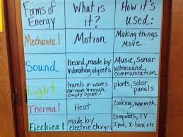
Use big sheets. One on each sheet students can answer columns.

