Light Waves
- How does light travel?
- How does light react to different objects and substances?
Vocabulary
- light waves
- electromagnetic spectrum
- angle of reflection
- angle of incidence
- reflect / reflection
- refract / refraction
- absorb / absorption

Movement of Light
- Light travels in the form of ___________________waves
- Light spreads out in all directions from its ___________
- Light travels in straight lines called rays
- Light travels at the “speed of ____________”186,282 miles per second or 299,792 kilometers per second
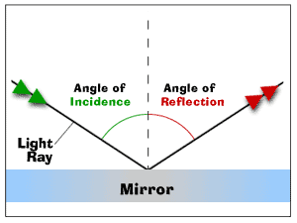
Reflection
- Reflection happens when light waves bounce off a ________________

Refraction
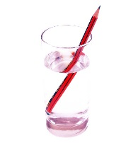
- Refraction happens when light ______ speeds and/or is bent (traveling from air to water)
Absorption
- Absorption of __________happens when atoms in an object absorb (take in and hold) the ___________waves.
For example: You are able to see a red apple because all of the other light ___________ are absorbed
but red is reflected to your eyes.

