  - Music vs. Noise
  - Resonance
  - ___________________
  - Interference
  - Acoustics
- Music
  - specific pitches and sound quality
  - regular _____________
- Noise
  - no definite ______________
  - no set pattern
- Forced Vibration
  - when one vibrating object _____________ another object to vibrate at the same frequency
  - results in a louder sound because a greater surface area is vibrating
  - used in ______________, pianos, etc.
- Resonance
  - special case of forced vibration
  - object is induced to vibrate at its natural frequency
- Fundamental
  - the lowest natural frequency of an object
- Overtones
  - multiples of the fundamental frequency
- Interference
  - the ability of 2 or more waves to combine to form a new wave

- Beats
  - variations in sound ___________produced by 2 slightly different frequencies
  - both _______________ and destructive interference occur

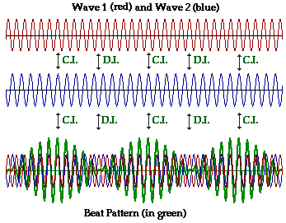

- Acoustics
  - the study of _______
- Reverberation
  - echo effect produced by the _________ of sound

