- Max Kenetic and Potential energy when looking at a ball on a string.

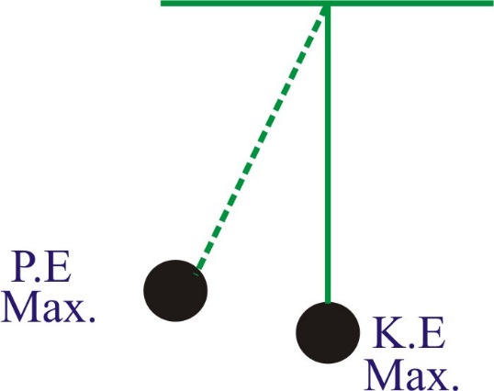

- In order to determine the object with the most potential energy you must look at which object below:
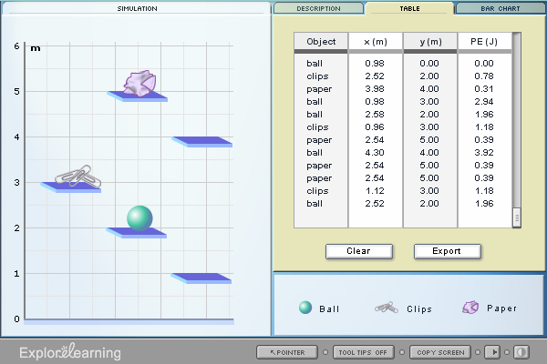

- The average kinetic energy can be measured by calculating the _______________.

- Know the following vocabulary terms: conduction, convection, radiation, insulator, conductor.

- The specific heat equation is energy = mass times specific heat times temperature change. Review the warm up we had on specific heat calculations.
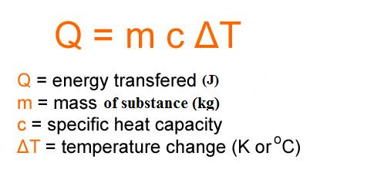
- A car burns fuel to power your vehicle which uses a battery. Which of the following types of energy is used by the car. (C)

    - Chemical, mechanical, electrical
    - Electrical, chemical, mechanical
    - Mechanical, chemical, electrical
    - Mechanical, electrical, chemical

- The human body uses which type of energy to break down food particles.

  - Heat energy.
  - Nuclear energy.
  - Chemical energy.

  - Mechanical energy.

- Refer to warm up examples in order to practice specific heat equations and calculate kinetic energy.

