1. Know the difference between high frequency and wavelength.
2. Long wavelength short frequency
3. High wavelength long frequency

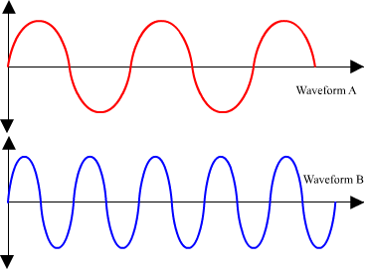

1. Know how the human ear hears sound.

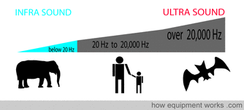

1. Know the difference in transverse and longitudinal wave.

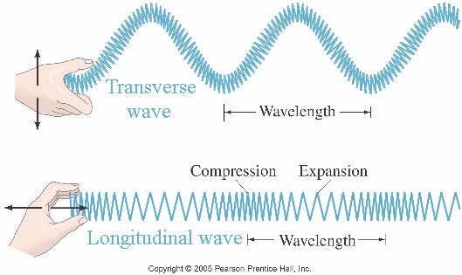

1. How is sound reflected?

As an echo

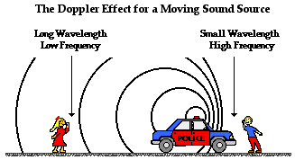

1. Know the doppler effect model.

Know your Sound Vocabulary (sample questions; not limited to these questions for the test):

1. The speed of the vibration is called ___________________.

A. Pitch

B. Rhythm

C. Frequency

7. Sound is a form of _____________________.

A. Energy

B. Work

C. Volume

8 Sound travels best through ___________________.

* + A. Water
  + B. Air
  + C. Solids

**9.**__________________ is the  highness or lowness of a sound.

* + A. Volume
  + B. Tension
  + C. Pitch
    - 1. A movement back and forth that produces sound is called _________________.

A. Vibration

B. Sound

C. Air

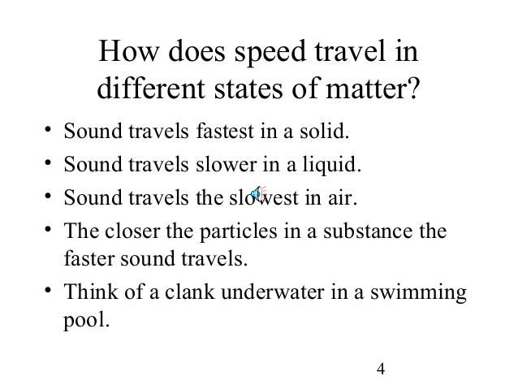

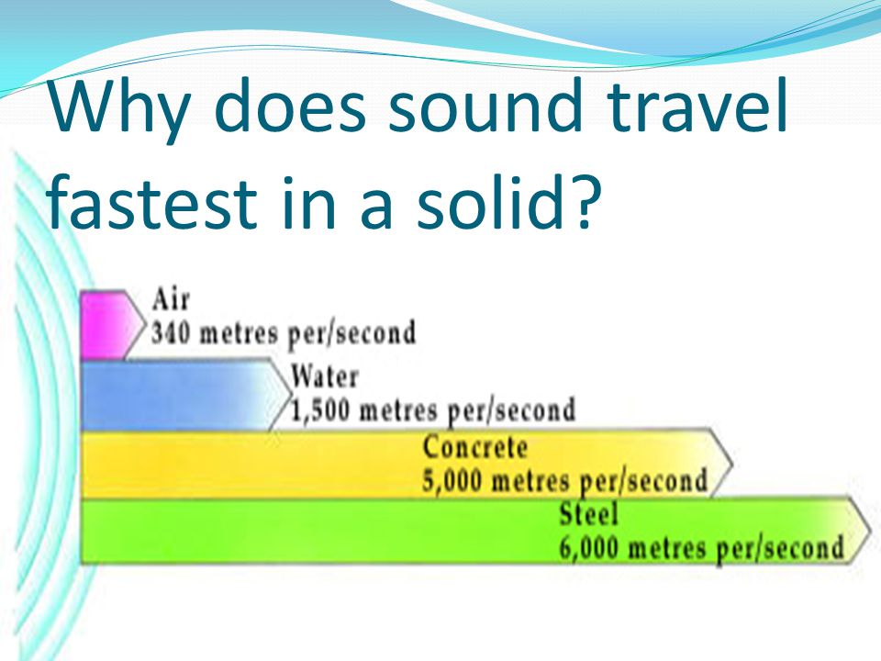

You will be asked to place items in order from best medium to worst medium. Sound travels best through which of the following medium?

Know how sound acts in a vacuum and under normal circumstances.

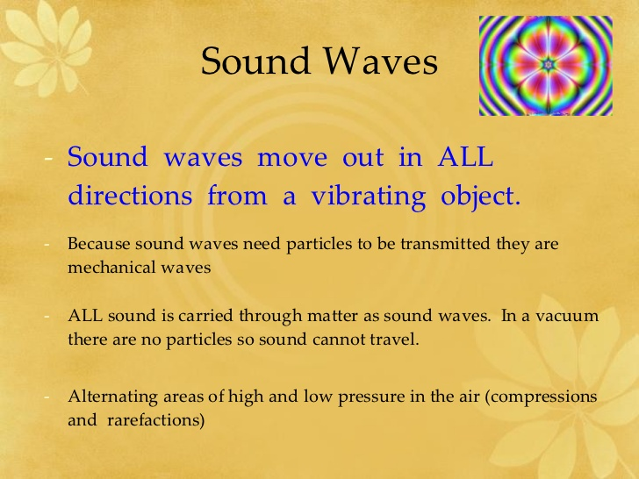

Know what a loud sound look like vs. a soft sound.

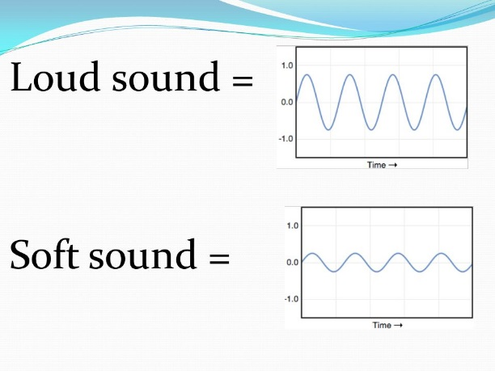

Know how sound travels through air.

