Transfer of Heat
Heat
- A form of energy associated with the motion of _______________ or molecules.
- Transferred from higher ____________________ objects to objects at a lower temperature.

Three ways heat can be transferred
- _________________________
- _________________________
- _________________________
Conduction
- Transfer of heat through direct ______________________.
- Occurs anytime objects at different temperatures are _________________ each other.
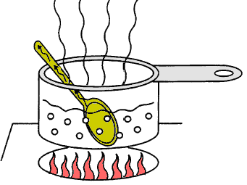
- As long as the objects are in contact, transfer of heat will continue until the temperature of the _______________ is the same.
Example:

Conductors and Insulators
- Some materials conduct ____________ better than others.
- Materials that transfer heat well are called ___________________.
- Metals are usually good conductors.
- Wood, paper and plastic are not.
- Materials that stop the transfer of heat are called _______________ (styrofoam, wool, fiberglass).
Convection
- The transfer of energy in a_________________ or gas.
- When part of a gas or liquid is heated, the particles it is made up of move______________ and spread out more.
- The moving particles bump into other particles, causing them to move faster and spread out more.
Radiaiton
- Energy transferred in the form of rays or ________________ or particles.
- We will concentrate on the type of radiation that travels as ______________ waves.
Electromagnetic Waves
- Include visible light,_____________________ and infrared light
- Can travel through space.
- The ___________ is our major source.
More About Convection
- Convection is warmer at the earth’s _____________so air near the earth’s surface is heated by the earth.
- Warmer, less dense air rises.
- It is cooler higher up in the atmosphere, so the air becomes more _____________ again and begins to fall.
- Sinking air moves under warmer air and it all starts over again.

Convection Currents in the Mantle

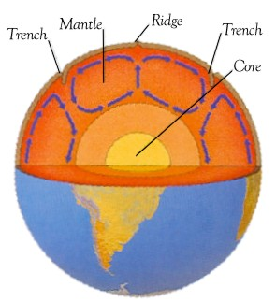
- There is a lot of heat within the earth.
- The surface of the earth is cooler than the lower mantle.
- Heat is transferred to the upper layers.
- Spots where the material conducts more heat become hotter and less dense, so they rise towards the surface.
- Denser material falls.

