1. 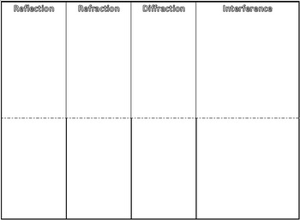Interference

1

1. Destructive Interference

2

1. Define
2. Picture
3. Constructive Interference
4. Define
5. Picture
6. Interference of Light
7. Define

4

1. Example with Picture

3

1. Interference of Sound
2. Define
3. Example with Picture
4. Standing Wave

5

1. Define

6

1. Example with Picture
2. Nodes and Anti Nodes

Split this tap in two

1. Define Each

7

1. Picture

8

1. Diffraction
2. Define
3. Example with Picture
4. Refraction
5. Define
6. Example with a Picture
7. Reflection
8. Define
9. Example with Picture

1a1. 1a2

1b1. 1b2

a

b

a

b

b

a

a

b

b

a

a

b

b

a