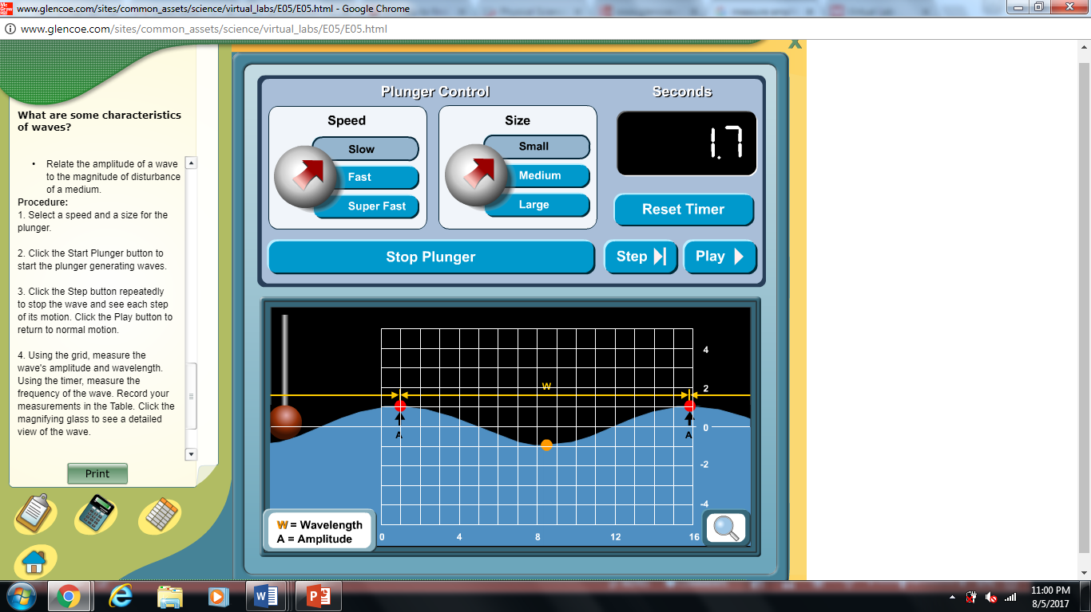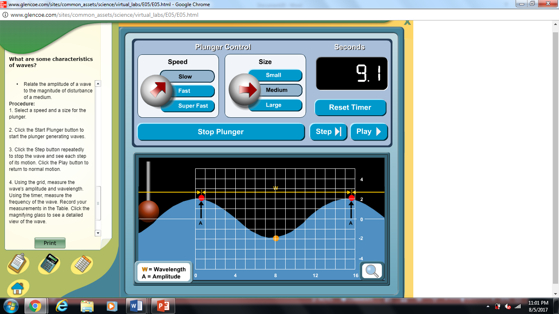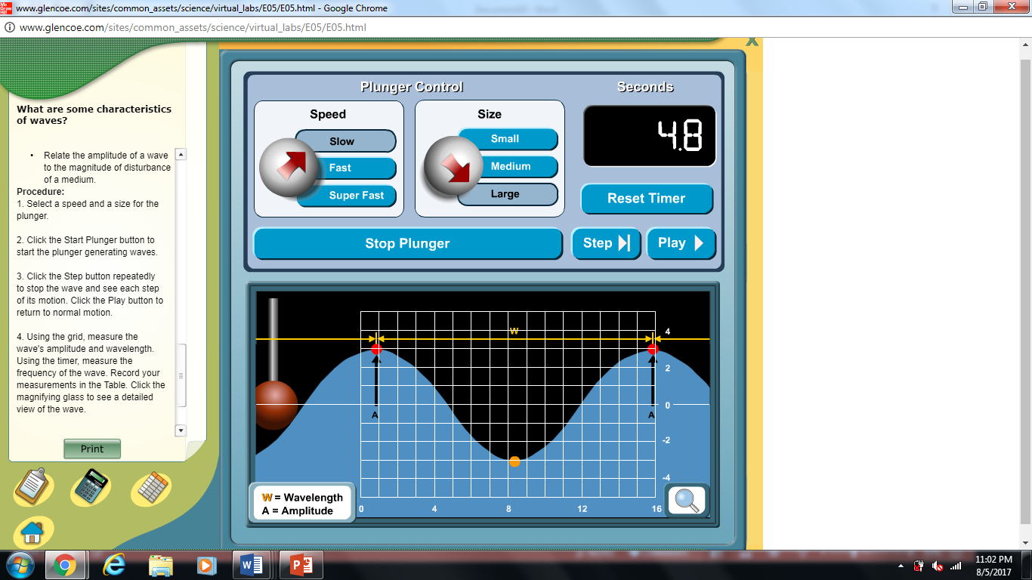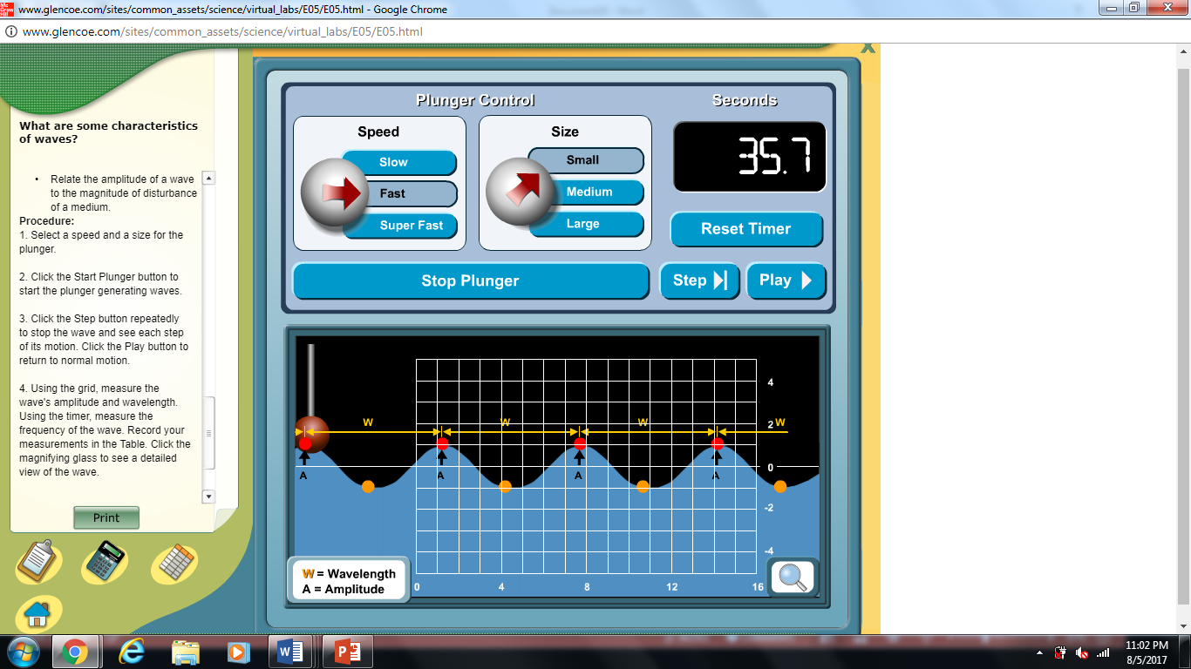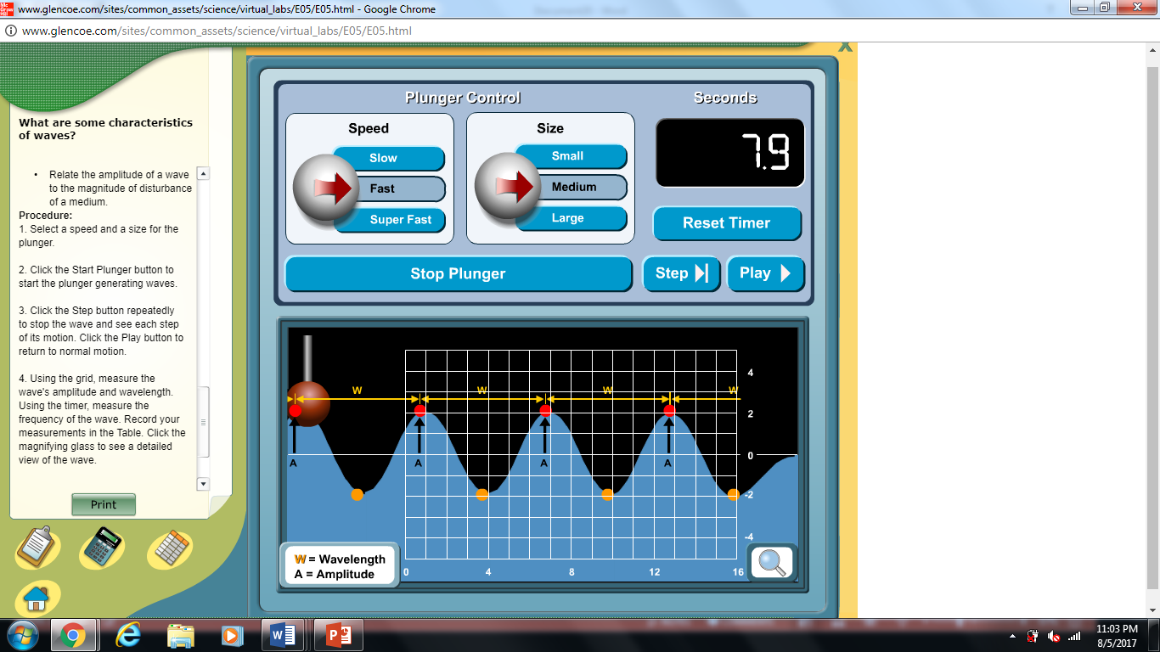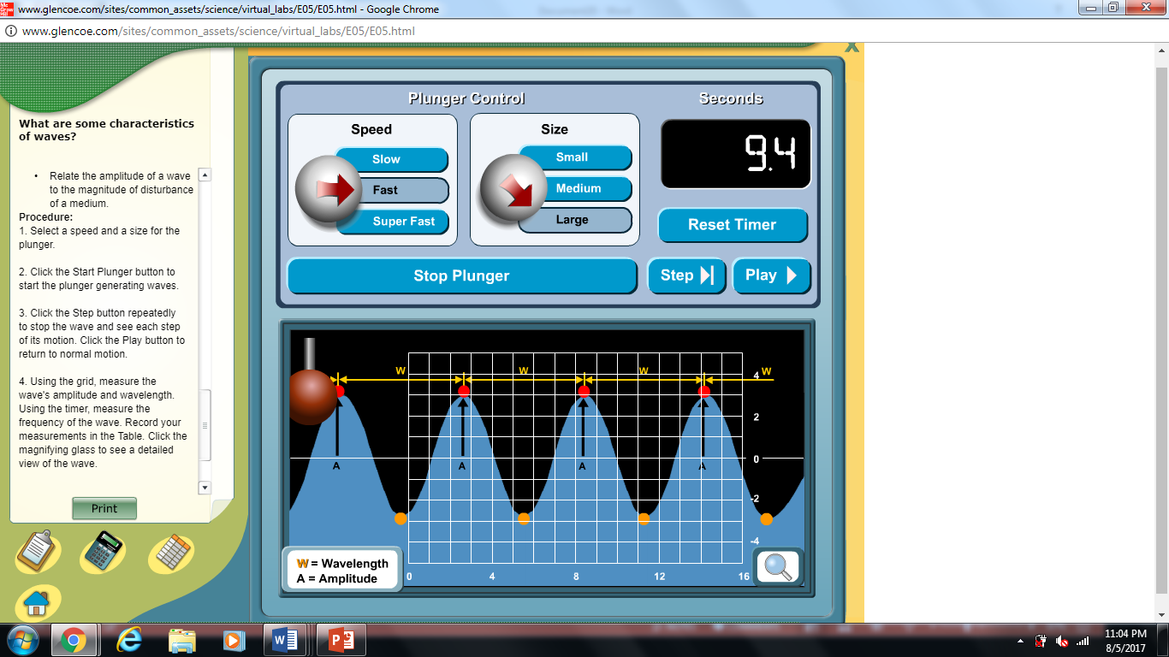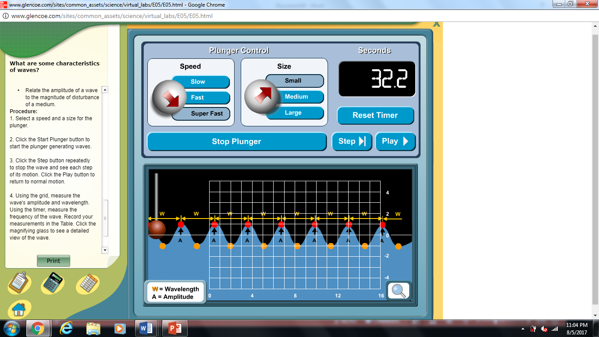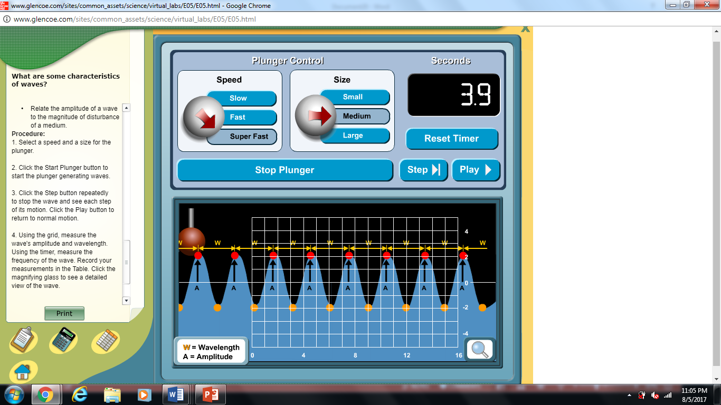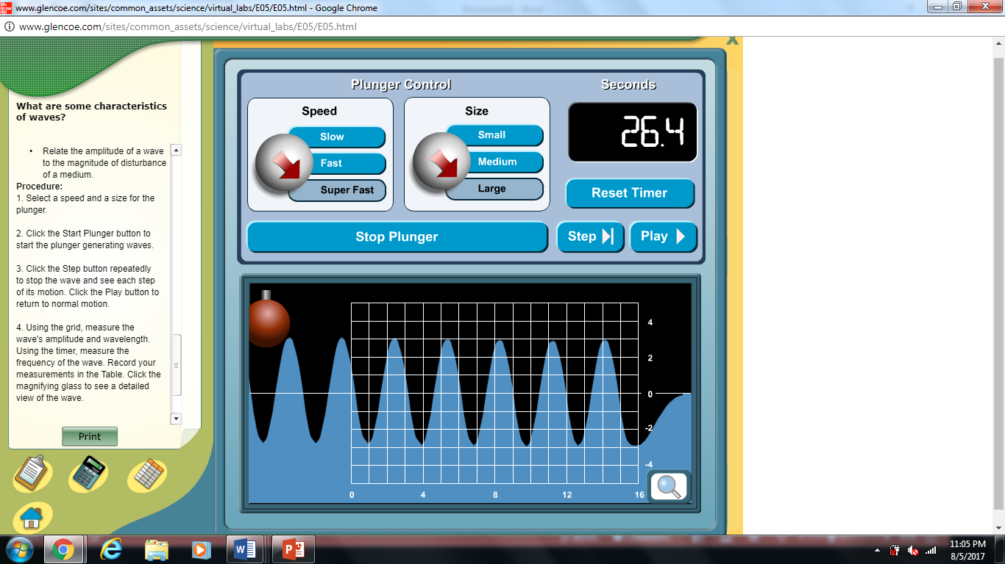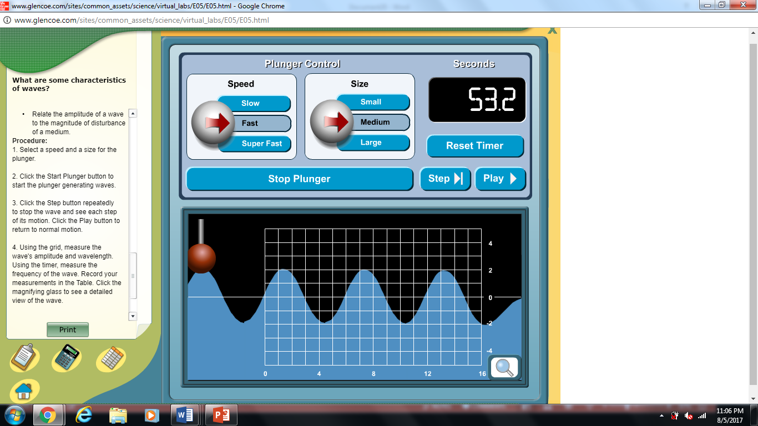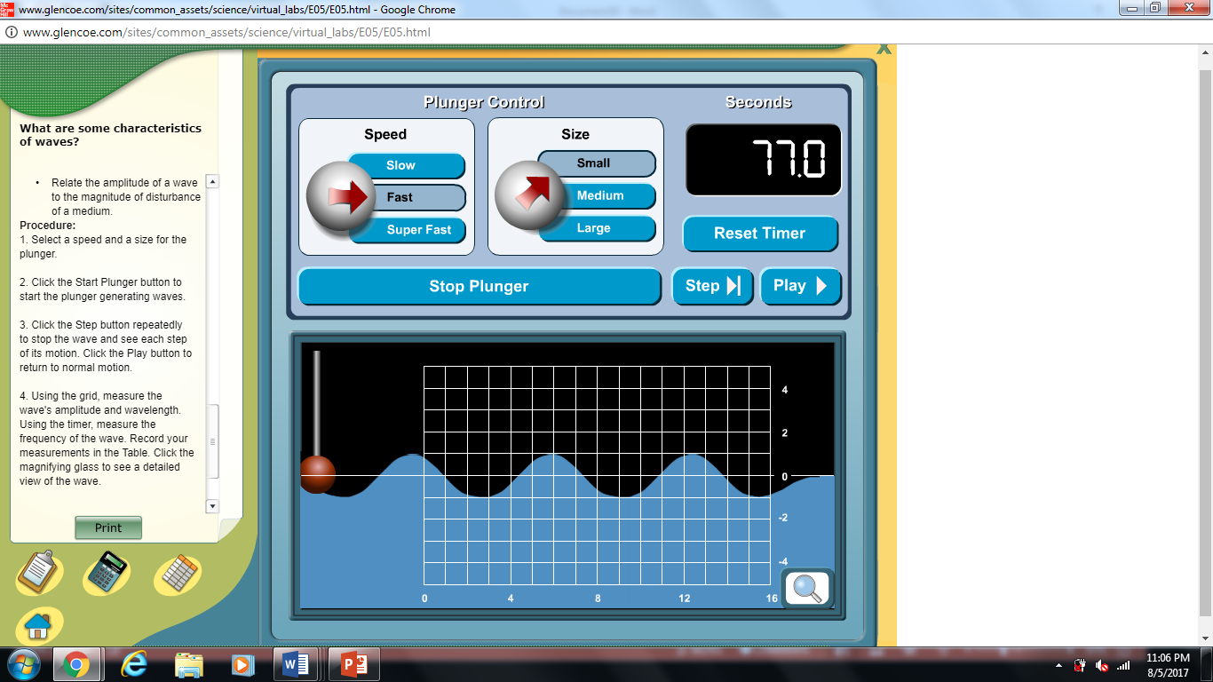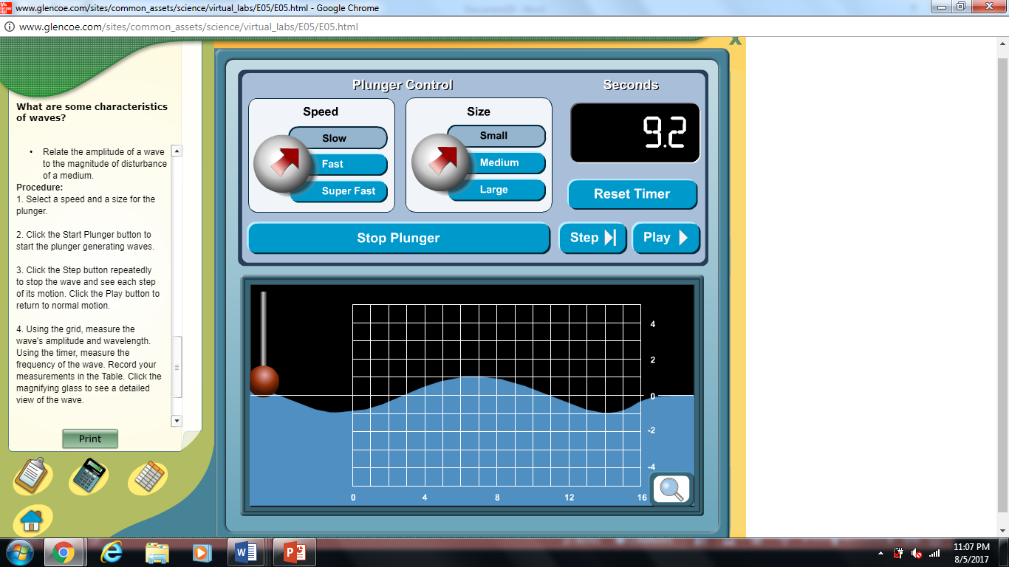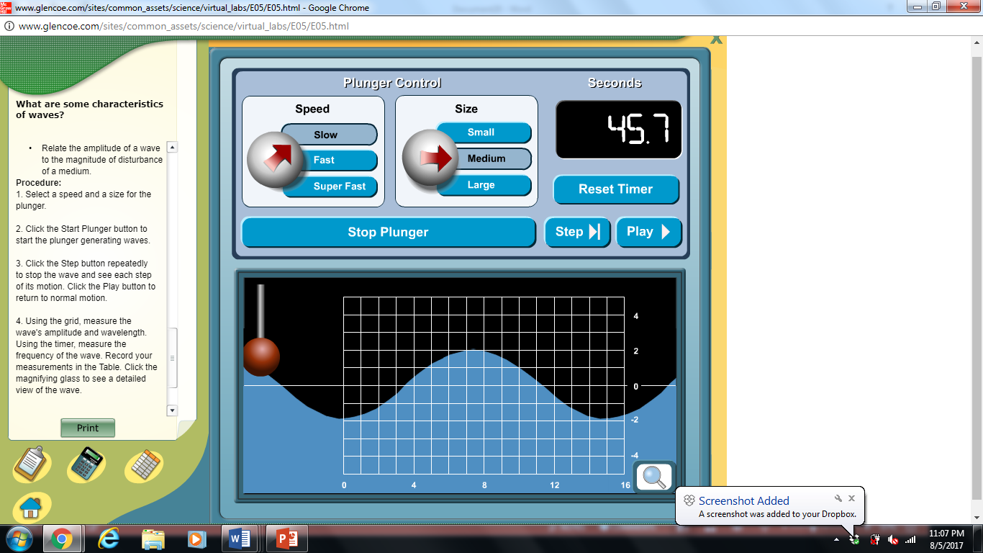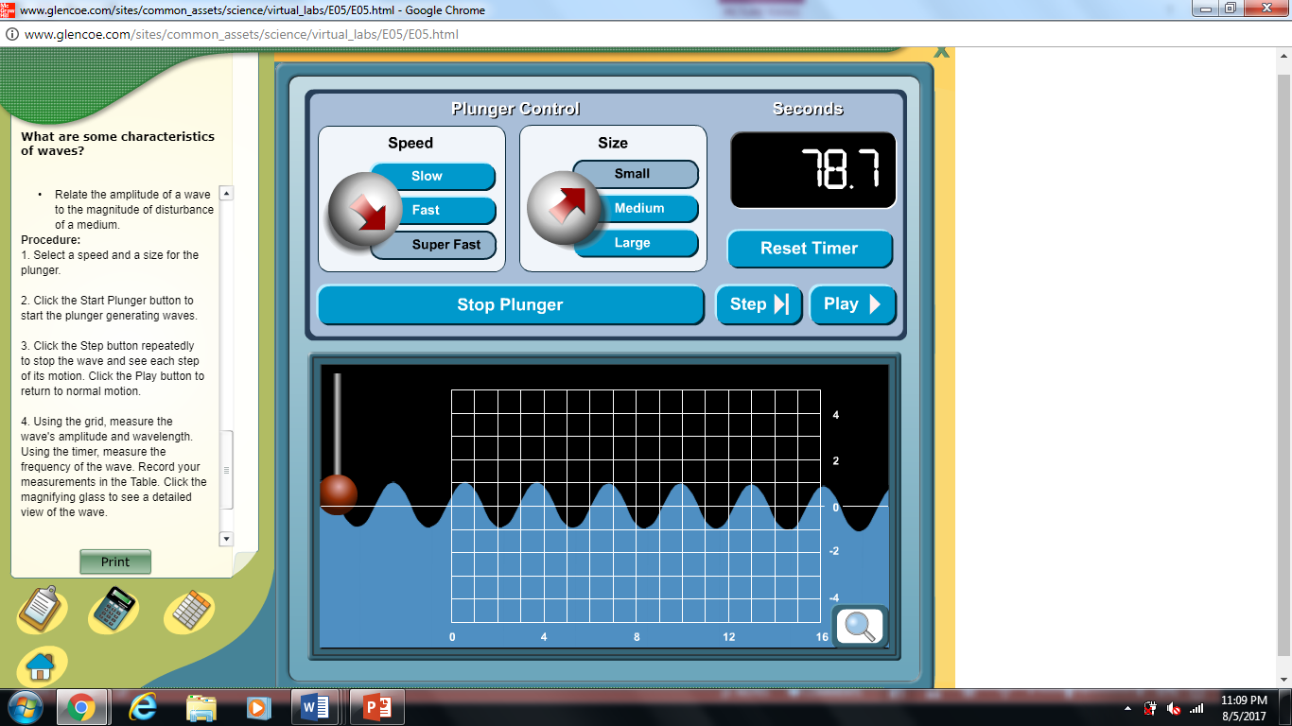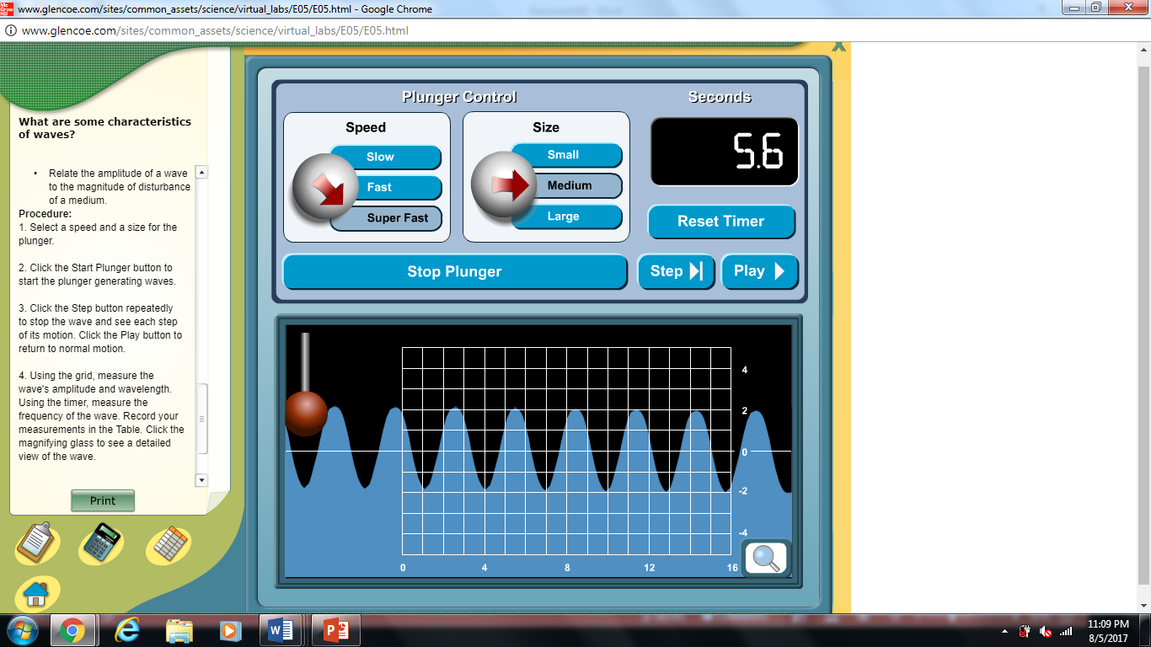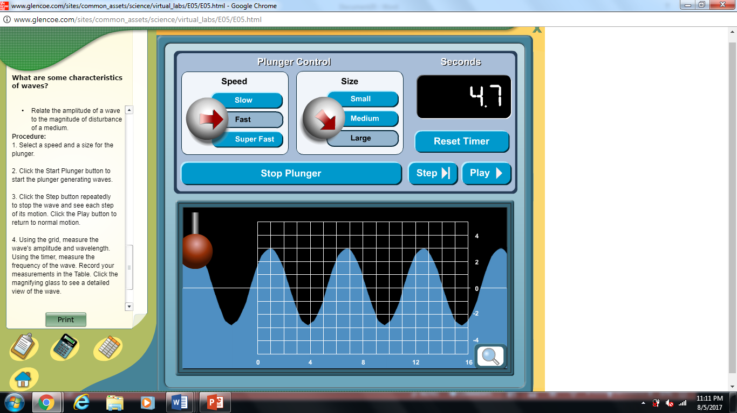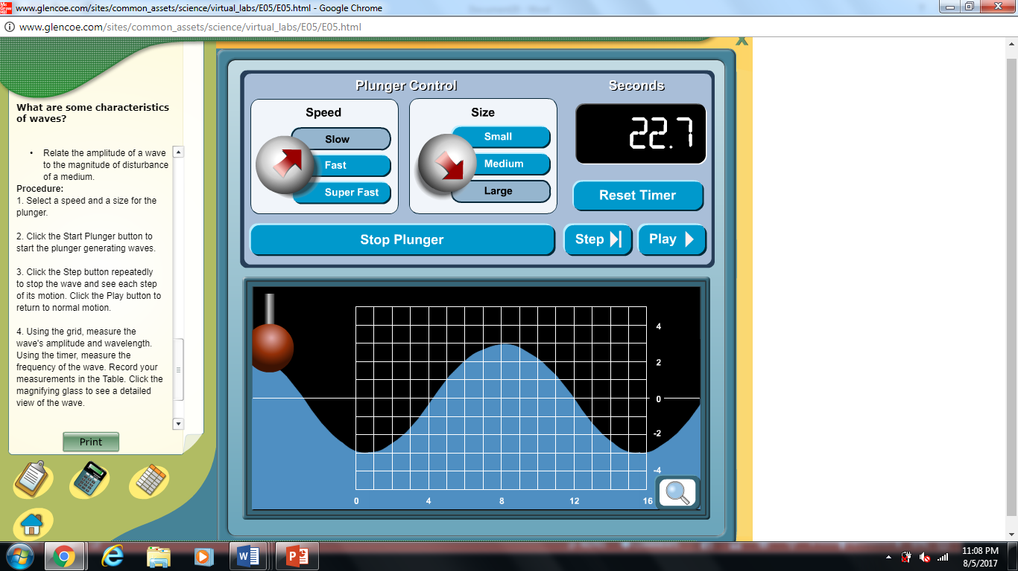

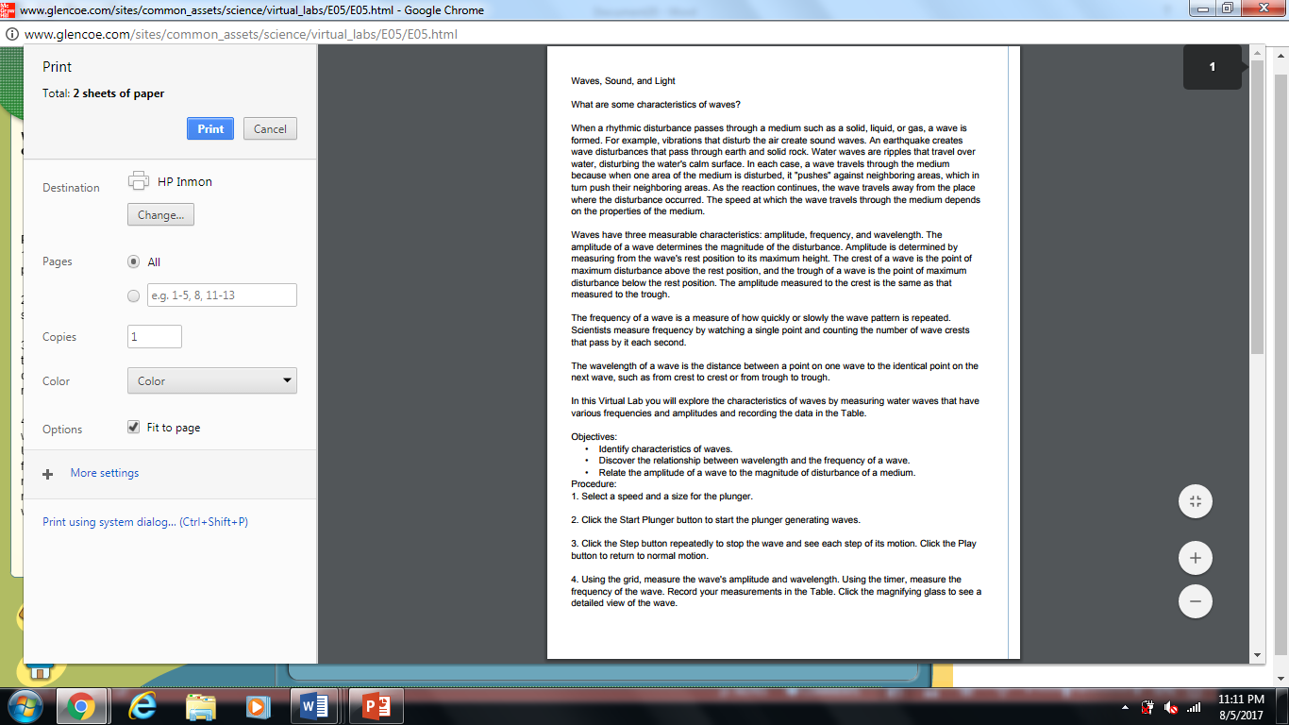

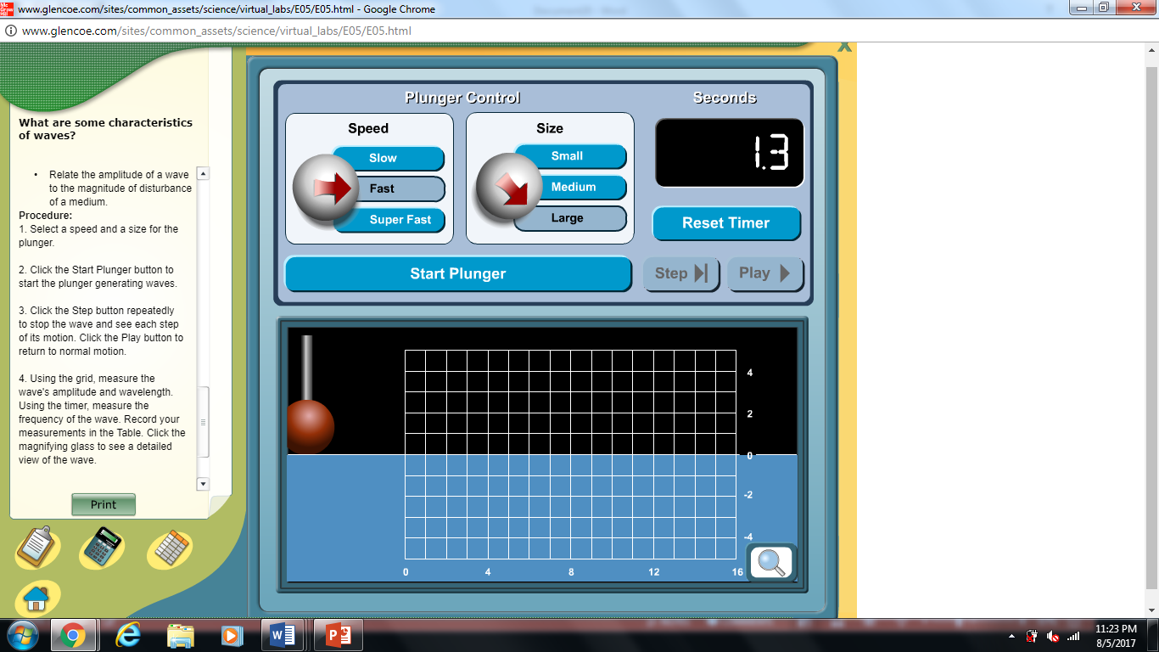

1. Names of your group member’s and group number.
2. Hypothesize which speed and size will produce the largest and smallest waves.
3. Investigate which waves are the largest or smallest by viewing the graphs around the room.
4. Record the data you discover. Calculate amplitude and wavelength on the given charts, then attempt the unknown.
5. Draw a quick sketch of each graph you investigate.
6. Explain the relationship between speed and size in 3-4 sentences. How do these two characteristics affect the wavelength and amplitude?
7. How would you calculate the speed of each wave? Where could you use the wave technology above in everyday life?
8. You need to do at least 5 graphs in your lab for full credit. Repeat 4 and 5 for each example. Calculate at least one unknown.

7

6

4

5

5

4

4

2

5

5

4

5

4

1