Characteristics of Waves
  - Waves
  - _______________________ waves
  - Longitudinal waves
  - Measuring waves
- Waves
  - rhythmic _____________________ that carry energy through matter or space
- Medium
  - material through which a wave transfers energy
  - solid, liquid, gas, or ______________________
  - electromagnetic waves don’t need a medium (e.g. visible light)
- Two Types:
Longitudinal Transverse
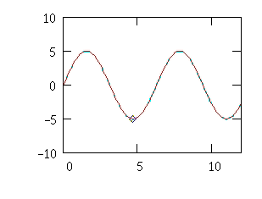
- Transverse Waves
  - medium moves perpendicular to the direction of wave motion

- Longitudinal Waves (a.k.a. compressional)
  - _____________ moves in the same direction as wave motion
- Frequency ( f )
  - # of waves passing a point in 1 second
  - Hertz (Hz)
  - shorter wavelength ⇒ higher ___________ ⇒ higher energy

